-----------------------------------------------------------------------------------------------VOICE ENABLED AI ASSISTANT
-----------------------------------------------------------------------------------------------

Overview
The project focuses on building a voice-enabled query system that allows users to interact with large-scale data using natural language (voice or text). Instead of writing complex SQL queries or navigating dashboards, users can simply ask questions, and the system intelligently processes them to return meaningful insights.
The system integrates speech processing, language understanding, and AI-driven query generation over a data lake architecture. It is designed to be scalable, user-friendly, and suitable for both technical and non-technical users.
The core goal is to bridge the gap between raw data storage (data lake) and intuitive data access, enabling faster and more accessible decision-making.

Our Approach
We adopted a layered AI-driven architecture that separates concerns across frontend interaction, backend flow, and intelligent query processing.

Key Design Principles:
- Modularity → Each component (STT, LLM, retrieval) is independent
- Scalability → Works with large data lake systems
- Real-time interaction → Supports streaming voice processing
- AI-first design → LLMs handle intent understanding and query generation

Core Strategy:
- Convert voice → text
- Understand user intent using LLMs
- Map intent to structured queries
- Retrieve data from data lake
- Convert results into human-readable response (text/voice)
This ensures a seamless pipeline from user input → insight output.

Architecture Diagram
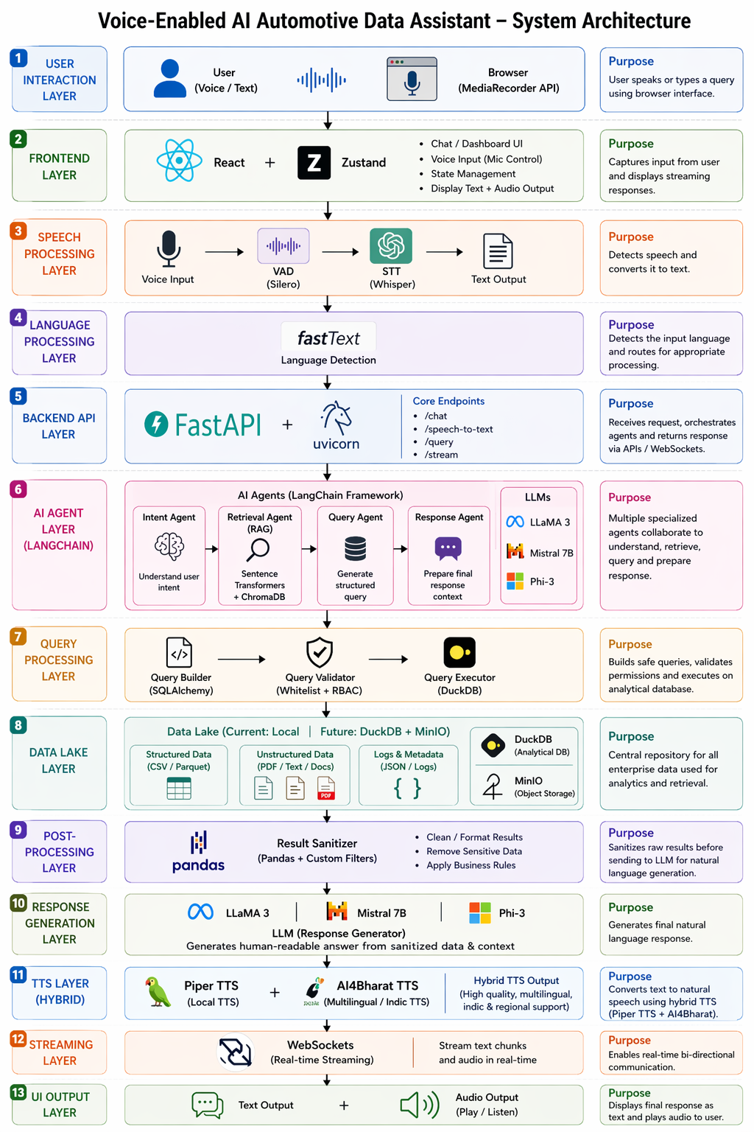

Workflow
- User Input
  - User provides input via voice or text
- Voice Processing
  - Voice Activity Detection (VAD) filters noise
  - Speech-to-Text (STT) converts speech into text
- Language Detection
  - Identifies the language (supports multilingual queries)
- Backend Processing (FastAPI)
  - Receives processed input
  - Routes request to AI layer
- AI Agent Layer
  - Intent Agent → Understands what the user wants
  - Retrieval Agent (RAG) → Fetches relevant data context
  - Query Agent → Converts intent into executable queries
- Data Lake Query Execution
  - Query runs on structured/unstructured data sources
- Response Generation
  - Output formatted into natural language
- Text-to-Speech (Optional)
  - Converts response into voice output

Features Included

1. Voice + Text Input
- Supports natural interaction
- Eliminates need for technical query knowledge

2. Multilingual Support
- Detects and processes multiple languages
- Enables broader accessibility

3. AI-Based Query Understanding
- Converts vague queries into structured data operations
- Handles ambiguity using LLM reasoning

4. Retrieval-Augmented Generation (RAG)
- Combines LLM knowledge with real data
- Ensures accurate and context-aware answers

5. Real-Time Processing
- Streaming-based architecture for faster responses

6. Data Lake Integration
- Works with large-scale, unstructured data
- No strict schema dependency

7. Role-Based Access Control (Basic)
- User/Admin roles for controlled access

8. Voice Output (TTS)
- Supports multiple accents (e.g., American, British)
- Improves accessibility and UX

Tech Stack

1. Frontend
Technology: React + Zustand

Why Chosen:
- Lightweight and fast state management (Zustand)
- Component-based UI → easy scalability
- Good support for real-time features (voice streaming)

Why Not Others:
- Redux → Too complex for this scale
- Angular → Heavier and less flexible for rapid prototyping

2. Backend
Technology: FastAPI + Uvicorn

Why Chosen:
- High performance (async support)
- Easy integration with AI/ML pipelines
- Automatic API documentation

Why Not Others:
- Flask → Not optimized for async workloads
- Django → Overkill for microservice-based architecture

3. Speech Processing

STT: Whisper
- High accuracy across languages
- Works well with noisy inputs

VAD: Silero
- Lightweight and efficient
- Reduces unnecessary processing

Why Not Others:
- Google STT → Paid and API-dependent
- Vosk → Lower accuracy compared to Whisper

4. Language Detection
Technology: fastText

Why Chosen:
- Fast and lightweight
- Supports multiple languages

Why Not Others:
- Langdetect → Less accurate
- Heavy NLP models → unnecessary overhead

5. AI / LLM Layer
Models: LLaMA 3, Mistral 7B, Phi-3

Why Chosen:
- Open-source and cost-effective
- Strong performance for reasoning and query generation
- Can be self-hosted → better data privacy

Why Not Others:
- GPT APIs → costly and external dependency
- Smaller models → weaker reasoning capability

6. Data Layer
Technology: Data Lake + DuckDB

Why Chosen:
- Handles structured + unstructured data
- DuckDB enables fast local querying
- No strict schema requirement

Why Not Traditional Databases:
- Databases require predefined schema
- Not suitable for large, raw datasets

7. Retrieval Layer
Technology: RAG (Vector DB optional like FAISS)

Why Chosen:
- Enhances LLM accuracy with real data
- Reduces hallucination

Why Not Pure LLM:
- LLM alone lacks real-time data access
- Higher risk of incorrect responses

8. Streaming Layer
Technology: WebSockets

Why Chosen:
- Real-time bidirectional communication
- Required for live voice interaction

Why Not SSE:
- SSE is one-way only
- Not suitable for interactive systems

9. Text-to-Speech
Options: Piper / gTTS

Why Chosen:
- Piper → offline, fast, customizable voices
- gTTS → simple and easy fallback

Why Not Others:
- Coqui → discontinued/less maintained
- Paid APIs → cost constraints

Conclusion
This system combines AI, speech processing, and data engineering to create a powerful interface for querying data lakes using natural language. By leveraging open-source tools and modular architecture, the solution remains scalable, cost-effective, and adaptable to real-world enterprise applications.

